**INDIA GENERAL ELECTIONS RESULT ANALYSIS 2024**

**Total Seats**

SELECT

DISTINCT COUNT (Parliament_Constituency) AS Total_Seats

FROM constituencywise_results



**What is the total number of seats available for elections in each state**

SELECT

s.State AS State_Name,

COUNT(cr.Constituency_ID) AS Total_Seats_Available

FROM

constituencywise_results cr

JOIN

statewise_results sr ON cr.Parliament_Constituency = sr.Parliament_Constituency

JOIN

states s ON sr.State_ID = s.State_ID

GROUP BY

s.State

ORDER BY

s.State;

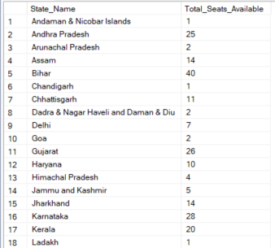 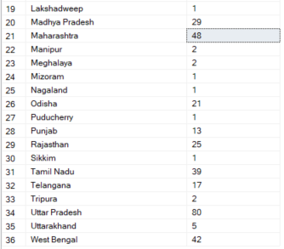

**Total Seats Won by NDA Allianz**

SELECT

SUM(CASE

WHEN party IN (

'Bharatiya Janata Party - BJP',

'Telugu Desam - TDP',

'Janata Dal (United) - JD(U)',

'Shiv Sena - SHS',

'AJSU Party - AJSUP',

'Apna Dal (Soneylal) - ADAL',

'Asom Gana Parishad - AGP',

'Hindustani Awam Morcha (Secular) - HAMS',

'Janasena Party - JnP',

'Janata Dal (Secular) - JD(S)',

'Lok Janshakti Party(Ram Vilas) - LJPRV',

'Nationalist Congress Party - NCP',

'Rashtriya Lok Dal - RLD',

'Sikkim Krantikari Morcha - SKM'

) THEN [Won]

ELSE 0

END) AS NDA_Total_Seats_Won

FROM

partywise_results

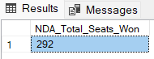

**Seats Won by NDA Allianz Parties**

SELECT

party as Party_Name,

won as Seats_Won

FROM

partywise_results

WHERE

party IN (

'Bharatiya Janata Party - BJP',

'Telugu Desam - TDP',

'Janata Dal (United) - JD(U)',

'Shiv Sena - SHS',

'AJSU Party - AJSUP',

'Apna Dal (Soneylal) - ADAL',

'Asom Gana Parishad - AGP',

'Hindustani Awam Morcha (Secular) - HAMS',

'Janasena Party - JnP',

'Janata Dal (Secular) - JD(S)',

'Lok Janshakti Party(Ram Vilas) - LJPRV',

'Nationalist Congress Party - NCP',

'Rashtriya Lok Dal - RLD',

'Sikkim Krantikari Morcha - SKM'

)

ORDER BY Seats_Won DESC

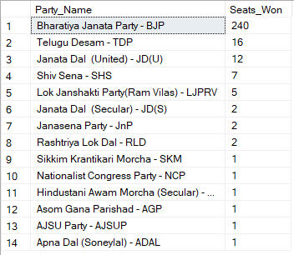

**Total Seats Won by I.N.D.I.A. Allianz**

SELECT

SUM(CASE

WHEN party IN (

'Indian National Congress - INC',

'Aam Aadmi Party - AAAP',

'All India Trinamool Congress - AITC',

'Bharat Adivasi Party - BHRTADVSIP',

'Communist Party of India (Marxist) - CPI(M)',

'Communist Party of India (Marxist-Leninist) (Liberation) - CPI(ML)(L)',

'Communist Party of India - CPI',

'Dravida Munnetra Kazhagam - DMK',

'Indian Union Muslim League - IUML',

'Nat`Jammu & Kashmir National Conference - JKN',

'Jharkhand Mukti Morcha - JMM',

'Jammu & Kashmir National Conference - JKN',

'Kerala Congress - KEC',

'Marumalarchi Dravida Munnetra Kazhagam - MDMK',

'Nationalist Congress Party Sharadchandra Pawar - NCPSP',

'Rashtriya Janata Dal - RJD',

'Rashtriya Loktantrik Party - RLTP',

'Revolutionary Socialist Party - RSP',

'Samajwadi Party - SP',

'Shiv Sena (Uddhav Balasaheb Thackrey) - SHSUBT',

'Viduthalai Chiruthaigal Katchi - VCK'

) THEN [Won]

ELSE 0

END) AS INDIA_Total_Seats_Won

FROM

partywise_results

**Seats Won by I.N.D.I.A. Allianz Parties**

SELECT

party as Party_Name,

won as Seats_Won

FROM

partywise_results

WHERE

party IN (

'Indian National Congress - INC',

'Aam Aadmi Party - AAAP',

'All India Trinamool Congress - AITC',

'Bharat Adivasi Party - BHRTADVSIP',

'Communist Party of India (Marxist) - CPI(M)',

'Communist Party of India (Marxist-Leninist) (Liberation) - CPI(ML)(L)',

'Communist Party of India - CPI',

'Dravida Munnetra Kazhagam - DMK',

'Indian Union Muslim League - IUML',

'Nat`Jammu & Kashmir National Conference - JKN',

'Jharkhand Mukti Morcha - JMM',

'Jammu & Kashmir National Conference - JKN',

'Kerala Congress - KEC',

'Marumalarchi Dravida Munnetra Kazhagam - MDMK',

'Nationalist Congress Party Sharadchandra Pawar - NCPSP',

'Rashtriya Janata Dal - RJD',

'Rashtriya Loktantrik Party - RLTP',

'Revolutionary Socialist Party - RSP',

'Samajwadi Party - SP',

'Shiv Sena (Uddhav Balasaheb Thackrey) - SHSUBT',

'Viduthalai Chiruthaigal Katchi - VCK'

)

ORDER BY Seats_Won DESC

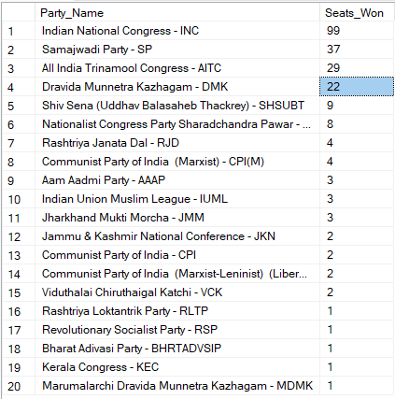

**Add new column field in table partywise_results to get the Party Allianz as NDA, I.N.D.I.A and OTHER**

ALTER TABLE partywise_results

ADD party_alliance VARCHAR(50);

**I.N.D.I.A Allianz**

**UPDATE partywise_results**

**SET party_alliance = 'I.N.D.I.A'**

**WHERE party IN (**

**'Indian National Congress - INC',**

**'Aam Aadmi Party - AAAP',**

**'All India Trinamool Congress - AITC',**

**'Bharat Adivasi Party - BHRTADVSIP',**

**'Communist Party of India (Marxist) - CPI(M)',**

**'Communist Party of India (Marxist-Leninist) (Liberation) - CPI(ML)(L)',**

**'Communist Party of India - CPI',**

**'Dravida Munnetra Kazhagam - DMK',**

**'Indian Union Muslim League - IUML',**

**'Jammu & Kashmir National Conference - JKN',**

**'Jharkhand Mukti Morcha - JMM',**

**'Kerala Congress - KEC',**

**'Marumalarchi Dravida Munnetra Kazhagam - MDMK',**

**'Nationalist Congress Party Sharadchandra Pawar - NCPSP',**

**'Rashtriya Janata Dal - RJD',**

**'Rashtriya Loktantrik Party - RLTP',**

**'Revolutionary Socialist Party - RSP',**

**'Samajwadi Party - SP',**

**'Shiv Sena (Uddhav Balasaheb Thackrey) - SHSUBT',**

**'Viduthalai Chiruthaigal Katchi - VCK'**

**);**

**NDA Allianz**

**UPDATE partywise_results**

**SET party_alliance = 'NDA'**

**WHERE party IN (**

**'Bharatiya Janata** Party - BJP',

'Telugu Desam - TDP',

'Janata Dal (United) - JD(U)',

'Shiv Sena - SHS',

'AJSU Party - AJSUP',

'Apna Dal (Soneylal) - ADAL',

'Asom Gana Parishad - AGP',

'Hindustani Awam Morcha (Secular) - HAMS',

'Janasena Party - JnP',

'Janata Dal (Secular) - JD(S)',

'Lok Janshakti Party(Ram Vilas) - LJPRV',

'Nationalist Congress Party - NCP',

'Rashtriya Lok Dal - RLD',

'Sikkim Krantikari Morcha - SKM'

);

**OTHER**

UPDATE partywise_results

SET party_alliance = 'OTHER'

WHERE party_alliance IS NULL;

**Which party alliance (NDA, I.N.D.I.A, or OTHER) won the most seats across all states?**

SELECT

p.party_alliance,

COUNT(cr.Constituency_ID) AS Seats_Won

FROM

constituencywise_results cr

JOIN

partywise_results p ON cr.Party_ID = p.Party_ID

WHERE

p.party_alliance IN ('NDA', 'I.N.D.I.A', 'OTHER')

GROUP BY

p.party_alliance

ORDER BY

Seats_Won DESC;

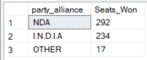

**Winning candidate's name, their party name, total votes, and the margin of victory for a specific state and constituency?**

SELECT cr.Winning_Candidate, p.Party, p.party_alliance, cr.Total_Votes, cr.Margin, cr.Constituency_Name, s.State

FROM constituencywise_results cr

JOIN partywise_results p ON cr.Party_ID = p.Party_ID

JOIN statewise_results sr ON cr.Parliament_Constituency = sr.Parliament_Constituency

JOIN states s ON sr.State_ID = s.State_ID

WHERE s.State = 'Uttar Pradesh' AND cr.Constituency_Name = 'AMETHI';



**What is the distribution of EVM votes versus postal votes for candidates in a specific constituency?**

SELECT

cd.Candidate,

cd.Party,

cd.EVM_Votes,

cd.Postal_Votes,

cd.Total_Votes,

cr.Constituency_Name

FROM

constituencywise_details cd

JOIN

constituencywise_results cr ON cd.Constituency_ID = cr.Constituency_ID

WHERE

cr.Constituency_Name = 'MATHURA'

ORDER BY cd.Total_Votes DESC;

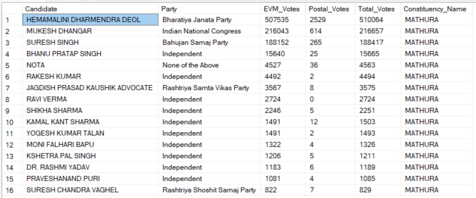

**Which parties won the most seats in s State, and how many seats did each party win?**

SELECT

p.Party,

COUNT(cr.Constituency_ID) AS Seats_Won

FROM

constituencywise_results cr

JOIN

partywise_results p ON cr.Party_ID = p.Party_ID

JOIN

statewise_results sr ON cr.Parliament_Constituency = sr.Parliament_Constituency

JOIN states s ON sr.State_ID = s.State_ID

WHERE

s.state = 'Andhra Pradesh'

GROUP BY

p.Party

ORDER BY

Seats_Won DESC;

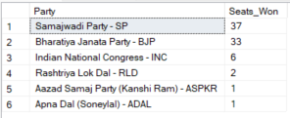

**What is the total number of seats won by each party alliance (NDA, I.N.D.I.A, and OTHER) in each state for the India Elections 2024**

SELECT

s.State AS State_Name,

SUM(CASE WHEN p.party_alliance = 'NDA' THEN 1 ELSE 0 END) AS NDA_Seats_Won,

SUM(CASE WHEN p.party_alliance = 'I.N.D.I.A' THEN 1 ELSE 0 END) AS INDIA_Seats_Won,

SUM(CASE WHEN p.party_alliance = 'OTHER' THEN 1 ELSE 0 END) AS OTHER_Seats_Won

FROM

constituencywise_results cr

JOIN

partywise_results p ON cr.Party_ID = p.Party_ID

JOIN

statewise_results sr ON cr.Parliament_Constituency = sr.Parliament_Constituency

JOIN

states s ON sr.State_ID = s.State_ID

WHERE

p.party_alliance IN ('NDA', 'I.N.D.I.A', 'OTHER') -- Filter for NDA and INDIA alliances

GROUP BY

s.State

ORDER BY

s.State;

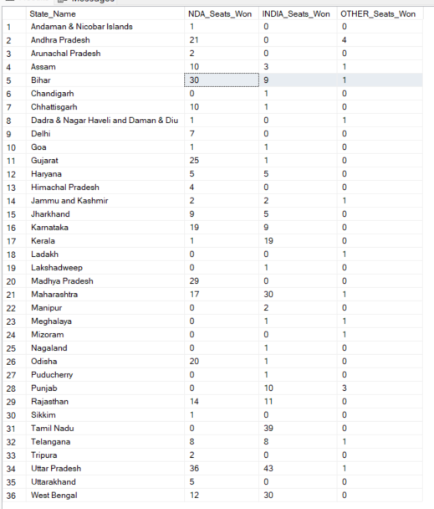

**Which candidate received the highest number of EVM votes in each constituency (Top 10)?**

SELECT TOP 10

cr.Constituency_Name,

cd.Constituency_ID,

cd.Candidate,

cd.EVM_Votes

FROM

constituencywise_details cd

JOIN

constituencywise_results cr ON cd.Constituency_ID = cr.Constituency_ID

WHERE

cd.EVM_Votes = (

SELECT MAX(cd1.EVM_Votes)

FROM constituencywise_details cd1

WHERE cd1.Constituency_ID = cd.Constituency_ID

)

ORDER BY

cd.EVM_Votes DESC;

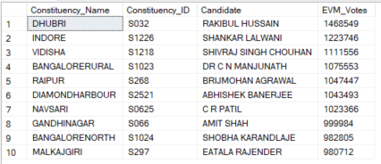

**Which candidate won and which candidate was the runner-up in each constituency of State for the 2024 elections?**

WITH RankedCandidates AS (

SELECT

cd.Constituency_ID,

cd.Candidate,

cd.Party,

cd.EVM_Votes,

cd.Postal_Votes,

cd.EVM_Votes + cd.Postal_Votes AS Total_Votes,

ROW_NUMBER() OVER (PARTITION BY cd.Constituency_ID ORDER BY cd.EVM_Votes + cd.Postal_Votes DESC) AS VoteRank

FROM

constituencywise_details cd

JOIN

constituencywise_results cr ON cd.Constituency_ID = cr.Constituency_ID

JOIN

statewise_results sr ON cr.Parliament_Constituency = sr.Parliament_Constituency

JOIN

states s ON sr.State_ID = s.State_ID

WHERE

s.State = 'Maharashtra'

)

SELECT

cr.Constituency_Name,

MAX(CASE WHEN rc.VoteRank = 1 THEN rc.Candidate END) AS Winning_Candidate,

MAX(CASE WHEN rc.VoteRank = 2 THEN rc.Candidate END) AS Runnerup_Candidate

FROM

RankedCandidates rc

JOIN

constituencywise_results cr ON rc.Constituency_ID = cr.Constituency_ID

GROUP BY

cr.Constituency_Name

ORDER BY

cr.Constituency_Name;

***Query Explaination:***

**1. Common Table Expression (CTE) RankedCandidates**

* **WITH RankedCandidates AS**: This section creates a Common Table Expression (CTE) named RankedCandidates, which is used to rank candidates based on their total votes within each constituency.
* **SELECT ... FROM constituencywise_details cd**: This part of the CTE retrieves data from the constituencywise_details table, including:
  + cd.Constituency_ID: The ID of the constituency.
  + cd.Candidate: The name of the candidate.
  + cd.Party: The party of the candidate.
  + cd.EVM_Votes: The number of EVM votes received by the candidate.
  + cd.Postal_Votes: The number of postal votes received by the candidate.
  + cd.EVM_Votes + cd.Postal_Votes AS Total_Votes: The total votes received by the candidate (sum of EVM and postal votes).
* **ROW_NUMBER() OVER (PARTITION BY cd.Constituency_ID ORDER BY cd.EVM_Votes + cd.Postal_Votes DESC) AS VoteRank**:
  + ROW_NUMBER() is a window function that assigns a unique rank to each candidate within their respective constituency.
  + PARTITION BY cd.Constituency_ID ensures that the ranking is done separately for each constituency.
  + ORDER BY cd.EVM_Votes + cd.Postal_Votes DESC orders candidates by their total votes in descending order, so the candidate with the most votes gets rank 1.
* **JOIN ... ON ...**: Joins are performed to combine information from related tables:
  + constituencywise_results cr ON cd.Constituency_ID = cr.Constituency_ID
  + statewise_results sr ON cr.Parliament_Constituency = sr.Parliament_Constituency
  + states s ON sr.State_ID = s.State_ID
* **WHERE s.State = 'Maharashtra'**: Filters the results to include only data related to the state of Maharashtra.

**2. Main Query**

* **SELECT ... FROM RankedCandidates rc**: The main query retrieves data from the RankedCandidates CTE to find the winning and runner-up candidates for each constituency.
* **MAX(CASE WHEN rc.VoteRank = 1 THEN rc.Candidate END) AS Winning_Candidate**:
  + CASE WHEN rc.VoteRank = 1 THEN rc.Candidate END selects the candidate with the highest vote rank (rank 1) for each constituency.
  + MAX(...) ensures that only one candidate is selected for each constituency.
* **MAX(CASE WHEN rc.VoteRank = 2 THEN rc.Candidate END) AS Runnerup_Candidate**:
  + CASE WHEN rc.VoteRank = 2 THEN rc.Candidate END selects the candidate with the second highest vote rank (rank 2) for each constituency.
  + MAX(...) ensures that only one candidate is selected for each constituency.
* **JOIN ... ON ...**: Joins the RankedCandidates CTE with the constituencywise_results table to get the constituency names.
* **GROUP BY cr.Constituency_Name**: Groups the results by constituency name to ensure that the winning and runner-up candidates are determined for each constituency.
* **ORDER BY cr.Constituency_Name**: Orders the results alphabetically by constituency name for easier readability.

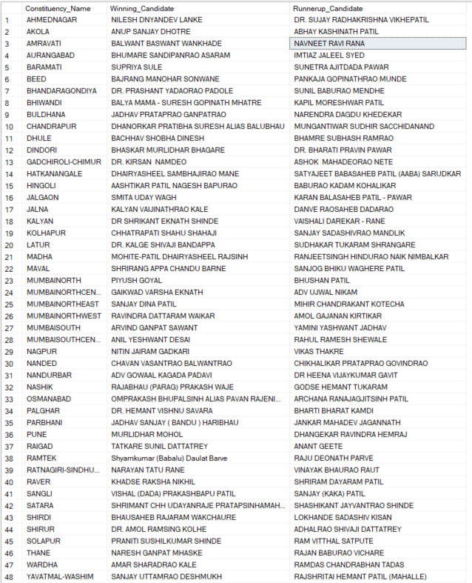

**For the state of Maharashtra, what are the total number of seats, total number of candidates, total number of parties, total votes (including EVM and postal), and the breakdown of EVM and postal votes?**

SELECT

COUNT(DISTINCT cr.Constituency_ID) AS Total_Seats,

COUNT(DISTINCT cd.Candidate) AS Total_Candidates,

COUNT(DISTINCT p.Party) AS Total_Parties,

SUM(cd.EVM_Votes + cd.Postal_Votes) AS Total_Votes,

SUM(cd.EVM_Votes) AS Total_EVM_Votes,

SUM(cd.Postal_Votes) AS Total_Postal_Votes

FROM

constituencywise_results cr

JOIN

constituencywise_details cd ON cr.Constituency_ID = cd.Constituency_ID

JOIN

statewise_results sr ON cr.Parliament_Constituency = sr.Parliament_Constituency

JOIN

states s ON sr.State_ID = s.State_ID

JOIN

partywise_results p ON cr.Party_ID = p.Party_ID

WHERE

s.State = 'Maharashtra';

